Year 7 Forces Assignment Friction and Bicycles

Name _________________________________. Due date _____________

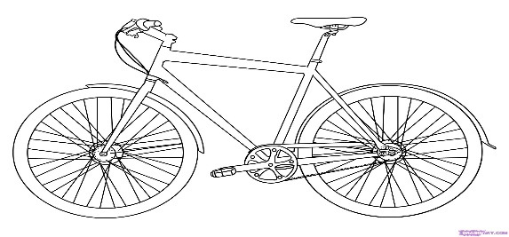

What you need to do:

1. Onto an A4 sheet of paper **draw** a simple diagram of a bicycle.
2. Onto the diagram label 4 places where friction is deliberately increased. Use the proper words for the parts. For example write pedal (not foot thingy).
3. Onto the diagram label 4 places where friction is deliberately decreased.
4. Onto a separate sheet of A4 paper set up a table. The table must have the following parts:
5. A column for the part of the bike being discussed.
6. A column stating if friction is deliberately being increased or decreased.
7. A column that states how the friction is being altered.
8. A column stating the reason the friction is being altered.
9. All the 8 parts labelled on the diagram must be covered in the table.

For example

|  |  |  |  |
| --- | --- | --- | --- |
| Bike part | Friction increased or decreased | How is friction altered? | Reason |
| Links of the Chain | Decreased | Lubrication. Oil is put on the chain. | Smoother movement of the chain. Less effort is needed to move the chain and in turn the bicycle. |
|  |  |  |  |
|  |  |  |  |

References. You must attach your references. You will need two references. Use the reference lay out shown in the diary.

Marking key

|  |  |  |  |
| --- | --- | --- | --- |
| Aspect |  | Possible mark | Your mark |
| Diagram | Suitable size | 1 |  |
|  | Heading | 1 |  |
|  | Labelled the 8 parts correctly | 4  0.5 each |  |
|  | Arrows point towards parts. | 1 |  |
| Table | Ruler used | 1 |  |
|  | Writing can be read clearly | 1 |  |
|  | All columns labelled | 1 |  |
|  | Correctly states if friction has been increased or decreased. | 8  One for each. |  |
|  | States how friction altered | 8 |  |
|  | States reason for altering friction | 8 |  |
| References | Must have at least 2.  Must use lay out shown in diary | 2 |  |
| Total |  | 36 |  |